**Additional Resources for Costume Sketch Project**

Canadian designer Judith Bowden talks about the role of the costume designer and how she approaches her work:

The main job of costume design in a production is to provide physical and emotional support to every actor through the clothing he or she will wear to enhance characterization. The costume must work onstage. This means it must provide comfort, flexibility and durability. At the same time the design must provide strong visual support of the story, concept and context of the play as a whole. It is my role to ensure that the costumes reflect the visual style of the production and help actors portray their characters on their journey through the play’s action.

I take my cues from the characters and their surroundings as written in the play, as well as from the stylistic choices of the production. In the same way that an actor builds upon the framework of traits and actions of his or her character in the story, I read what the character does and says for clues about what they might wear. I also need to think about how best to reflect a character’s evolution through the development of the story. Sometimes the character is best served by creating contrast between how a character behaves and what he or she looks like.

The Practicalities of the Job

Practically speaking, my job is to execute the design of each garment by:

•providing a costume sketch and research material

•providing a working drawing and/or discussing details of cut and fit with a cutter

•choosing the fabrics, trims, etc. for the garments

•participating in rehearsals to understand how the garment will be used and to ensure that stylistic choices made in initial discussions will still work as the production develops

•adjusting the design if required, to best suit the physique of the actor and the particulars of the character being portrayed

•keeping in mind the overall look and balance of each scene while making all choices and being aware of how colour schemes and silhouettes are developing the story of the play from scene to scene

•participating in fittings

•attending tech rehearsals, tech dress and dress rehearsals

•ensuring that the planning is translating onto the stage; adjusting and refining when necessary.

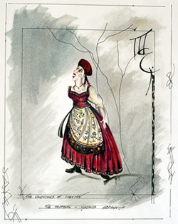

Natalya Stepanovna from The “Vaudevilles” of Chekhov / The Proposal (2003)

© Judith Bowden

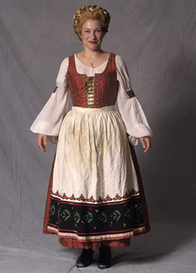

Christine Brubaker as Natalya Stepanovna from The “Vaudevilles” of Chekhov / The Proposal (2003), designed by Judith Bowden

© National Arts Centre

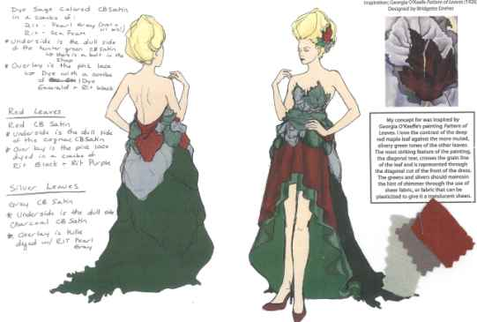

**[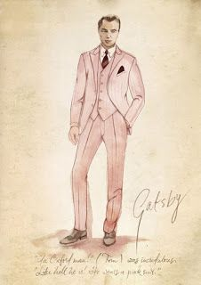](http://joannefergusonbridal.blogspot.co.uk/2013_05_01_archive.html)**