**Stagecraft 9-12**

Projections Assignment

While projection design is still relatively new (only around 30 years old) compared to the other elements (lighting, sound, scenic) it has revolutionized theatre arts. Today, projections are interwoven from small images to large across performing arts. From still images that represent ideas or locations to moving .gifs and films played either in loops or as whole performance aspects of a show, projections are amazing.

While projections are amazing, if you rely too heavily on them, you have lost some great artistic opportunities. Therefore, we must find some effective projections but also marry them with lighting, sound and scenic design.

**Assignment:**

1. Choose a show to work on:

**Shrek Shakespeare in Love Romeo and Juliet**

1. Choose a minimum of 5 major scenes from the play and find HD projections to fill
2. Using either Qlab or Powerpoint, create the digital slideshow with your projections including fades, dissolves, etc.
3. Insert transitions, Masks/layers, etc. (Don't worry if the 5 scenes are not right after each other!)

*Assessment:*

A – Student found interesting, HD images/.gifs/film and integrated them (more than 1 or 2 per scene) alongside each other (eg. Skyline is 1 image, the house is another and the door another. Projections relate to the story and help create the mood and marry well with the scenic and lighting design.

B – Logical, HD images found that relate to the story and help create the mood and marry well with the scenic and lighting design. Some layering of images done (more than 1 per scene) and

C- Some images provided (not all HD). Some work and relate, little or no layering/masking done and rarely or never more than 1 image per scene. Not all images help tell the story, are distracting or don't 'fit' together.

C-/Incomplete/Fail. The assignment is not completed or is missing major components. Little thought or effort has been put into the work. Needs to be resubmitted.

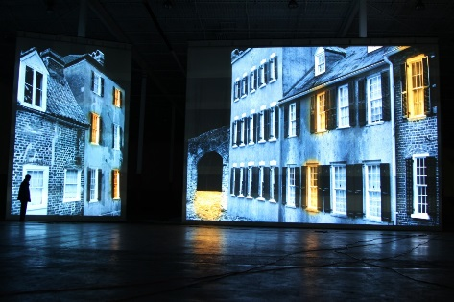 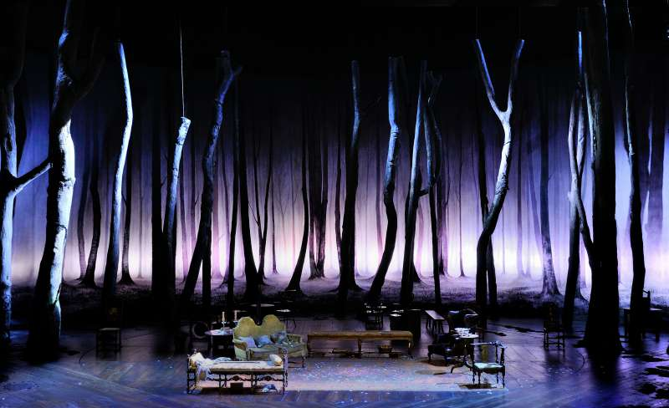 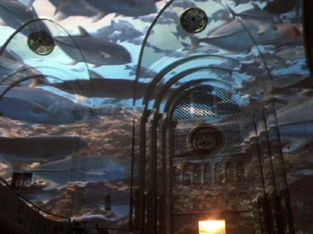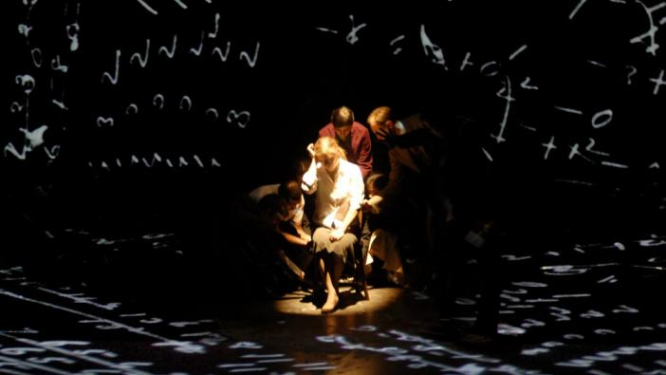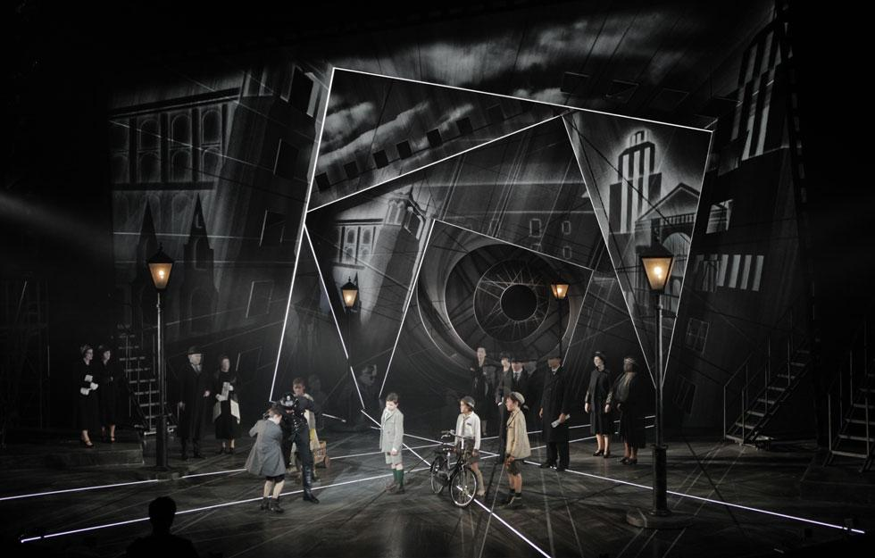

***Resources:***

** There is LOTS of info, programs, etc. available – if you want to work with something else, discuss it with your instructor but ABSOLUTELY do some online tutorials!

* Working in Projection Design: <https://www.youtube.com/watch?v=Y3n6q_ZyfJg>
* Why lighting is important to projections (keeping the light off the screen!) <https://www.youtube.com/watch?v=InrwJlaINKw>
* Using Surfaces in QLab: <https://www.youtube.com/watch?v=lxYYyKYKsOU>
* More projections in Qlab: <https://www.youtube.com/watch?v=EuDXVdg5QDo>
* Projection Mapping using PowerPoint: <https://www.youtube.com/watch?v=93ubF7zJiCo>
* Great projection mapping (Adobe After Effects) <https://www.youtube.com/watch?v=nWnGw_pDSIY>

Youtube searches:

* Projections
* Visuals
* Backgrounds
* ___________ Images
* ________.gifs