King Louis XIV Portrait Comparison

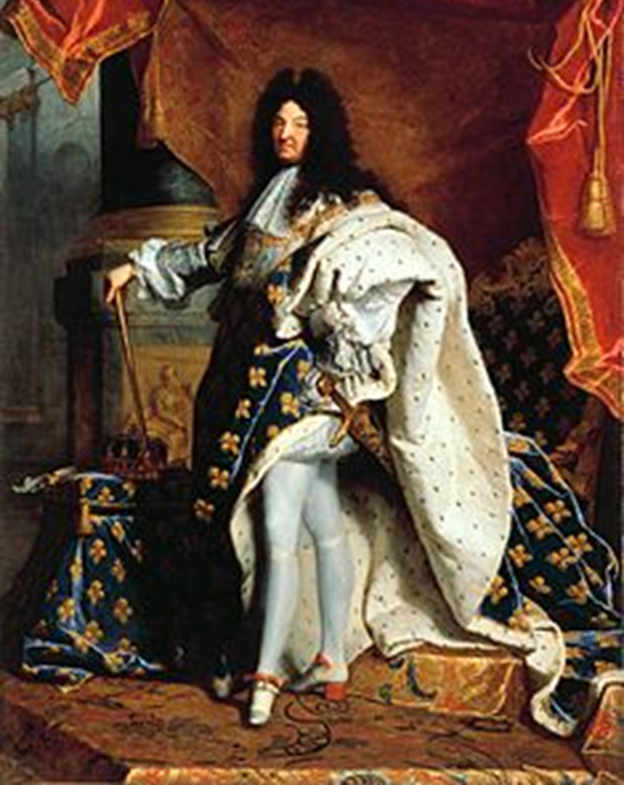

The official portrait of Louis XIV

Answer the following on a piece of paper:

1. Describe what you see.
2. What do you notice first?
3. What people and objects are shown?
4. What is the physical setting?
5. What impressions of characteristics (personality traits) does the portrait present?
6. How does the portrait’s point of view make Louis look?
7. What type of ruler do you think Louis would be judging by the portrait?

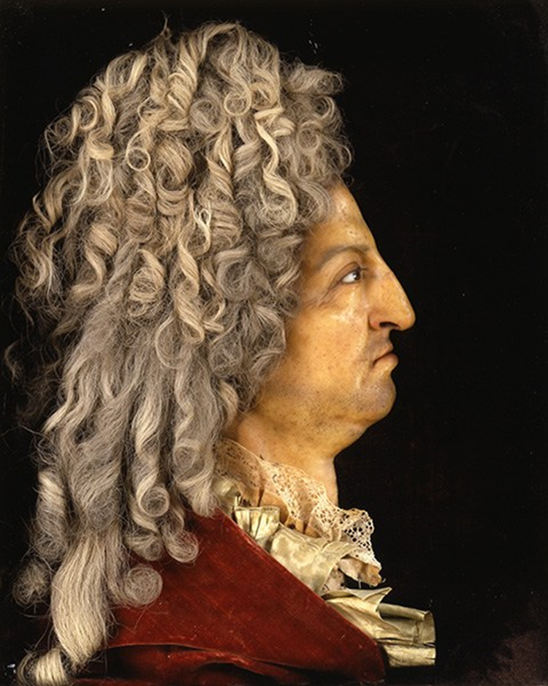

Wax Model of Louis XIV

* Answer the following questions on the same sheet of paper:

1. Describe what you see.
2. What do you notice first?
3. Are the facial features presented attractive or desirable? Why or why not?
4. What impressions of characteristics (personality traits) does the portrait present?
5. How does the portrait’s point of view make Louis look?
6. What type of ruler do you think Louis would be judging by the portrait?

Discuss with a partner:

What were some of the similarities between the official portrait and the wax model?

What were some of the differences between the official portrait and the wax model?

Write a paragraph response on the sheet of paper (4-7 sentences with evidence):

**How do you know this is not an official portrait commissioned by the royal family? Give reasons for your opinion and evidence from your analysis of the painting and the wax model.**

****Paragraph response due next class****