**Socials 9: Regions of Canada Project Name: Block:**

You have been asked by Canada's Ministry of Tourism to create a presentation to promote one of Canada's regions. You will be using Google slides for the main part of your presentation, but part of your mark for this project is for any additional presentation materials your group uses (costumes, music, food, posters, comics, etc). Be creative!!!

**Step 1:** Form groups of 3 to 4 students and draw for which region your group will be promoting.

**Step 2:** Divide tasks and topics among your group members. Fill out all the red areas on this sheet and print it off (2 sided). Give the entire groups sheets to me on presentation day so I can see how each group member contributed to the project!

**Step 3:** Begin your project by one team member creating a google slide. This person then shares this slide with other group members. Be sure to allow editing! You will be submitting this through our Google Classroom. Start your research – don't forget to cite your sources!! You may use the citation organizer to record your sources.

Your region:_____________________________________________________must include the following:

|  |  |
| --- | --- |
| Person(s) Responsible | Topics |
|  | **Title slide**: name of region, pictures, group members names |
|  | **Region Location**: provinces/territories, major cities |
|  | **Climate** graphs ( 2 different cities), average seasonal temperatures, rainfall, snowfall, days of sunshine |
|  | **Vegetation**-written and visuals of what grows there- forests or flat for agriculture (crops), types of trees, plants, soils |
|  | **Topography**-written and visuals of the physical features, mountain ranges and highest peaks, major lakes and rivers, plateaus, unique topography |
|  | **Economic activities**-what industries are there? What do people do for work? |
|  | **Demographics**: who lives there? Male/female, ages, nationalities, languages |
|  | **Tourist activities** |
|  | **Other**: Historical sites, famous landmarks, places of interest, Provincial Parks, Museums |
|  | Other **interesting facts** or details: ie: Famous people? Unique food or clothing? Songs? Traditions? |
| All group members | Bibliography Sources – final slide – all group members contribute to this. Include each person's name and list their sources. You may use the Read Write Think Citation Organizer. <http://www.easybib.com/> or <http://www.readwritethink.org/files/resources/lesson_images/lesson983/organizer-form.pdf> |

**\*\*Each topic is not limited to one slide!! You may need several to cover the topic with written information and pictures. You may change the order of the topics above.** Websites to help get you started:

<http://caen-keepexploring.canada.travel/>

<http://yourcanada.ca/>

<http://www.thecanadianencyclopedia.ca/en/article/physiographic-regions/>

<https://www.canada.ca/en/immigration-refugees-citizenship/corporate/publications-manuals/discover-canada/read-online/canadas-regions.html>

<http://web2.uwindsor.ca/edfac/student/griff-3.htm>

<https://sites.google.com/a/langleychristian.com/elementary/grade5/theme/canadian-regions>

<https://livelearn.ca/article/about-canada/canadas-five-regions/>

<http://climate.weather.gc.ca/climate_normals/index_e.html>

[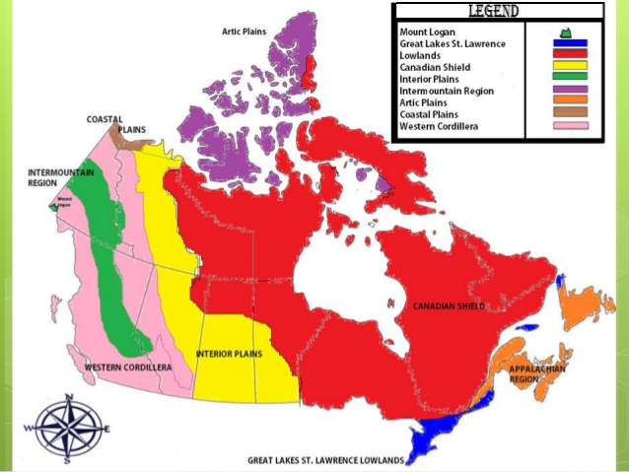](http://www.google.ca/url?sa=i&rct=j&q=&esrc=s&source=images&cd=&cad=rja&uact=8&ved=2ahUKEwjF8YXIpM7ZAhUK32MKHQ9XB40QjRx6BAgAEAY&url=http://vlc.ucdsb.ca/c.php?g%3D166446%26p%3D1115323&psig=AOvVaw1PoyKjcFCJKOCjS9y0fAJt&ust=1520102312587513)

**Regions of Canada Project Names: _____________________________**

|  |  |  |  |  |  |
| --- | --- | --- | --- | --- | --- |
|  | **Acquiring (1)** | **Developing (2)** | **Refining (3)** | **Mastering (4)** | **Extending (5)** |
| **Content** | Some of the required topics have been included, the included required topics need more detail and graphics are missing and or irrelevant. | Most of the required topics have been included. The presentation needs more details and has few graphics. | All required topics have been included, with a few details and graphics. | All required topics have been included, with several details and graphics. | All required topics have been included, with many details and graphics in an innovative way. Other information above what was required has been included that captures the region with mature insight. |
| **Sources**  **Includes a minimum of 3**  **Uses easybib.com or Read/Write/Think Citation Organizer** | A source is not used or a single source has not been cited. | 2 sources are used. The citations may be incomplete or improperly done. | 2-3 sources are used. Citing may not have been done properly. | 3 sources are used. Most citing has been done properly. | Multiple mixed-media sources are used and cited properly. |
| **Additional presentation materials**  (visuals, audio, costumes, music, food, posters, etc) | No additional materials are used, or additional materials are irrelevant. | One addition is used. | One or two additions are used in an applicable manner. Creative elements may be used to entertain and inspire others to see this region. | Several additions are used. Creative elements are used to entertain and inspire others to see this region. Materials are chosen to be engaging and successfully enhance the presentation. | The use of additional presentation materials is highly creative/innovative. |

**TOTAL: /12**

**Additional Comments:**

**Work Habits (Assessed as a group so make sure to keep your group members on task!)**

|  |  |  |
| --- | --- | --- |
| **G** | **S** | **N** |
| * Researches and works on project for entire class. * Does not disrupt others. * Always comes to class prepared. * Projects are fully completed by presentation date. | * Researches and works on project, but off task frequently. * Can be disruptive to others. * Usually comes to class with the required materials to work on the project. * Projects mostly completed by presentation date. | * Researches and works on project minimally in class. * Disruptive to others and off task * Does not come to class prepared (does not have required materials etc.) * Projects are incomplete and missing key information by presentation date. |